PICKLEBALL AUTOMATED POINT COUNTING USING AI
^{1*}Wong Tong Yung
¹Department of Network Computing, Faculty of Computer Science and Information Technology, Universiti Malaysia Sarawak, 94300 Kota Samarahan, Sarawak, Malaysia
email: ^{1*}87100@siswa.unimas.my,
*Corresponding author
Received: DD MM 20YY | Accepted: DD MM 20YY | Early access: DD MM 20YY

Abstract - Pickleball is currently experiencing exponential global growth. However, the unique officiating requirements present a significant barrier for recreational players. The sport utilizes a complex side-out scoring format where points are given to the serving team with a three number format. This issue imposes a cognitive burden on players, resulting in memory errors and on court disputes that disrupt gameplay flow. While professional tournaments utilize high-fidelity tracking systems, these solutions rely on expensive infrastructure that is inaccessible to recreational communities. To address this issue, this project aims to develop an affordable, automated scoring system that can be run on a standard consumer laptop with a USB webcam. The project integrates the YOLOv11-m object detection model, fine-tuned on a custom annotated dataset. A custom python-based game logic engine processes these coordinates to enforce server rotation and rally termination conditions. Data persistence is managed through SQLite database, ensuring offline functionality and facilitating post-match analytics. The system features a lightweight web-based dashboard that visualizes the live score and includes a video rewind feature for immediate dispute verification. This work demonstrates that high-level sports analytics can be democratized to enhance the recreational sports experience.

Keywords: Pickleball, Computer Vision, YOLOv11, Automated Scoring, Object Detection, Sports Analytics.

Introduction
Pickleball is currently the fastest-growing sport in Malaysia and globally, attracting a vast number of newcomers due to its low barrier to entry and social nature. However, the sport utilizes a side-out scoring format that differs from tennis or badminton. In this format. The points are only awarded to the serving team, and the score is announced as a three-number sequence. For reference, the serving teams score, the receiving teams score, and the server number. This non-linear scoring structure imposes a significant cognitive burden on recreational players. They must track these variables while actively playing, making the process highly prone to human error, frequently resulting in on-court disputes that disrupt the flow and enjoyment of the game.

While technology has transformed sports officiating, existing solutions remain largely inaccessible to the average recreational player. Professional optical tracking systems, such as Hawk-Eye, offer high fidelity but require expensive multi-camera infrastructure and permanent installation (Faiza, 2025; Ziegler, 2013). In the consumer market, mobile applications like SwingVision utilize smartphone processing but are often restricted to specific ecosystems such as Apple iOS, and it imposes a subscription fees for automated scoring features (SwingVision, 2026). For the dedicated hardware solutions, such as the In/Out device, introduce operational friction by requiring users to charge and calibrate fragile equipment for every match (On Court | In/Out, 2017).

To address these limitations, this paper presents a low-cost, automated pickleball scoring system designed to run on standard consumer laptops. The proposed solution integrates the YOLOv11-m object detection model to track match events in real-time using a single USB webcam. YOLOv11 was selected over architecture like Faster R-CNN or SSD due to the good performance in tracking real time and small-object detection capabilities (Ghoury et al., 2019; Li et al., 2021; Redmon et al., 2016; Ren et al., 2017). The system employs a python-based game logic engine to enforce server rotation rules and logs all match data into a local SQLite database. This functionality ensuring the system can be run in offline and data persistence. This project aims to democratize sports analytics by providing a reliable, accessible alternative to expensive commercial systems.

Literature Review

Existing Commercial Solutions
The landscape of automated sports officiating is currently divided into professional and consumer tiers. At the professional level, optical tracking systems such as Hawk-Eye are the industry standard. These systems utilize a synchronized array of 6–10 high-speed cameras to triangulate ball position. However, this technology relies on permanent infrastructure and on-site server processing, with installation costs often exceeding $100,000, making it inaccessible for recreational venues (Faiza, 2025; Ziegler, 2013).

In the consumer segment, solutions like SwingVision leverage the Neural Processing Units (NPUs) of modern smartphones to track gameplay. While accessible, SwingVision is restricted to the Apple ecosystem and locks essential features, such as automated scoring, behind recurring subscription models (SwingVision, 2026). Alternatively, dedicated hardware devices like the In/Out system offer a portable solution. However, they introduce significant operational friction, requiring users to purchase, charge, and calibrate proprietary equipment for every match, which disrupts the casual nature of recreational play (On Court | In/Out, 2017).

Object Detection Algorithms
Selecting an appropriate object detection architecture is critical for tracking high-velocity projectiles like pickleballs. Two-stage detectors, such as Faster R-CNN, employ a Region Proposal Network (RPN) to generate candidate boxes before classification. While highly accurate, this two-step process is computationally expensive, typically yielding frame rates below 10 FPS on standard hardware, which is insufficient for real-time sports tracking.

Conversely, one-stage detectors like Single Shot MultiBox Detector (SSD) improve speed by eliminating the region proposal stage. However, SSD architectures often struggle with detecting small objects due to lower-resolution feature maps (Li et al., 2021). The YOLO family of algorithms addresses these limitations by framing detection as a single regression problem, allowing for real-time inference speeds suitable for capturing fast-moving balls (Redmon et al., 2016). Specifically, the YOLOv11 architecture utilized in this project offers an optimized balance of speed and small-object detection capabilities compared to its predecessors (Jocher et al., 2023).

Methodology
The development of the automated pickleball scoring system follows a waterfall model methodology. This approach prioritizes the validation of the core Artificial Intelligence (AI) component specifically the computer vision module. Before integrating with the application logic, the process is divided into four distinct stages which is the data collection, model training, game logic development, and system integration.

Hardware and Software Implementation
The proposed system is designed to operate on standard consumer hardware to ensure accessibility. The primary processing unit is a laptop equipped with an NVIDIA GPU to support CUDA acceleration for the PyTorch framework. Video input is captured via a standard USB webcam configured to a resolution of 1080p at 60 Frames Per Second (FPS). The high frame rate is essential to minimize motion blur, which significantly degrades detection accuracy for small, fast-moving objects (Jiao et al., 2019). On the software side, the core logic is implemented in Python 3.9+, utilizing the OpenCV library for frame preprocessing and the Ultralytics YOLO framework for model inference (Jocher et al., 2023).

Data Collection and Preparation
To ensure accurate detection in real-world environments, a custom dataset was curated by recording actual pickleball gameplay using a standard USB webcam set to 1080p resolution. The camera was positioned at a fixed point to capture the full court view. The environment also needed to be consistent for the lighting and angles. Raw video footage was then used to processed into individual frames using the OpenCV library and manually annotated using Roboflow tools. Bounding boxes were drawn around the pickleball in each frame to define the object of interest (Jiao et al., 2019). Preliminary validation of the annotation pipeline was conducted using proxy objects, as shown in Figure 1, to verify the workflow before on-court data collection. The annotated dataset was subsequently partitioned into a Training Set (70%), Validation Set (20%), and Testing Set (10%) to ensure rigorous evaluation.
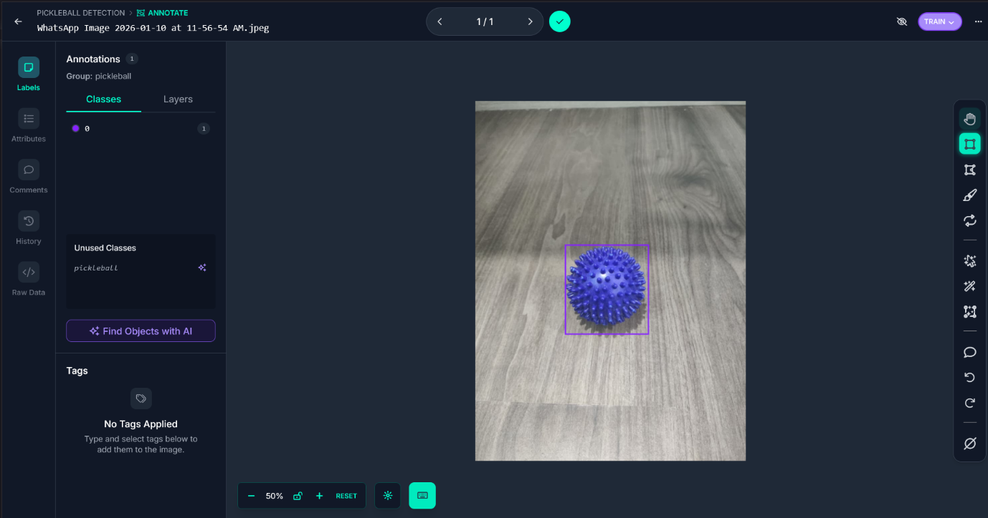
Figure 1: Illustration of the bounding box annotation workflow using a proxy object for preliminary testing

Core Detection Module
The system utilizes the YOLOv11-m architecture for object detection (Jocher et al., 2023). The model was selected because of the optimal balance between inference speed and detection accuracy compared to traditional methods (Zhao et al., 2019). The model is fine-tuned on the custom dataset using the PyTorch deep learning framework. The primary objective during training is to maximize the mean Average Precision (mAP), ensuring the model can consistently track the small, high-velocity ball across varying frames without missed detections (Liu et al., 2019). Iterative adjustments are made to the hyperparameters until high-confidence detection is achieved to support real-time tracking.

Game Logic and Database
A custom Python-based logic engine serves as a finite state machine to enforce the specific rules of pickleball. This engine interprets the coordinates provided by the vision module to determine rally outcomes. It specifically manages the complexity of traditional side-out scoring, tracking the Serving Team Score, Receiving Team Score, and Server Number. Figure 2 illustrates the activity flow used to enforce these rules. Concurrently, a local SQLite database is implemented to log every significant game event with a precise timestamp. This ensures the system operates entirely offline and preserves match data for post-game analysis.
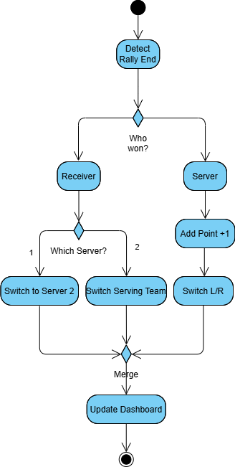
Figure 2: Activity Diagram of Pickleball Scoring Rules

System Integration and User Interface
In the final phase, the independent components are integrated into a unified prototype. The geometric coordinates generated by the YOLOv11 module are fed directly into the game logic engine to update the match state. The output is visualized on a user dashboard developed using standard web technologies. As shown in Figure 3, the interface is divided into three functional zones which is live video feed, dynamic scoreboard displaying the three-number score, a control panel use for starting, end the system and a video rewind function for verifying disputed calls.
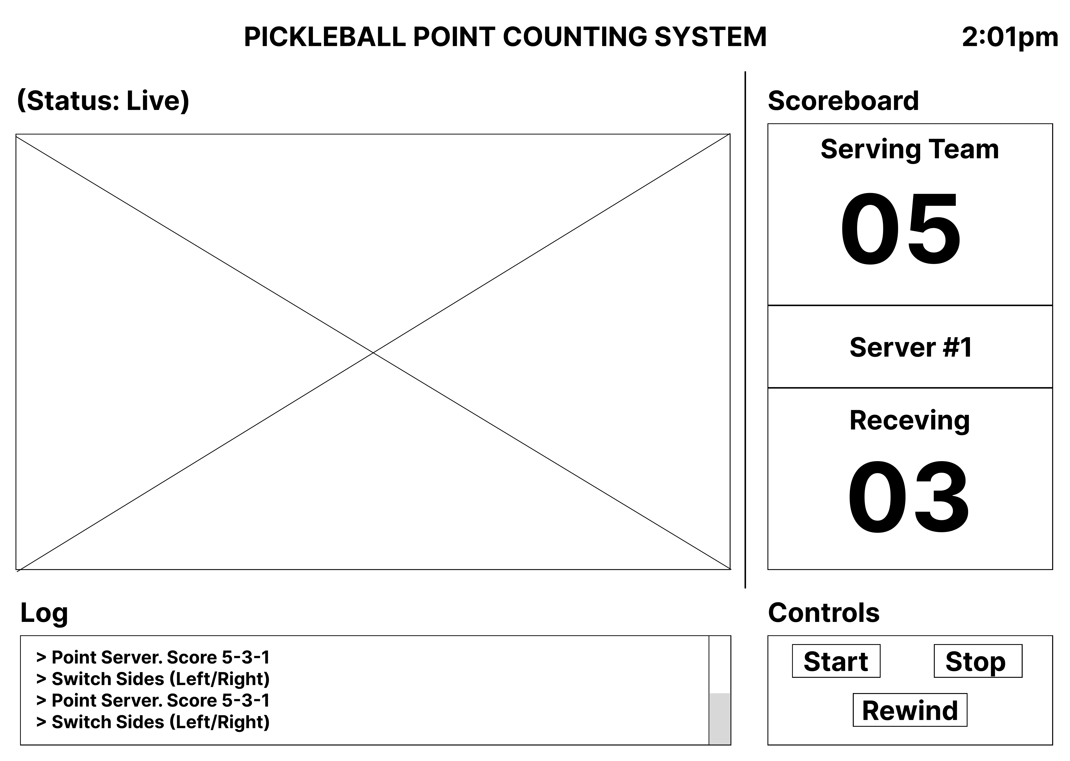
Figure 3: Graphical User Interface of the scoreboard

Proposed Evaluation Framework
To validate the performance of the system, a two-phase evaluation strategy will be employed. The first phase focuses on measuring the Mean Average Precision (mAP) of the YOLOv11 model against a reserved testing set. Additionally, the inference speed will be monitored to ensure it consistently exceeds 30 FPS on the target hardware.
Finally, a field test will be conducted in a live match environment. The performance of the system will be validated by comparing the automated scoring output against a manual score. This comparison will verify the ability of the system to correctly track the three-number score and identify side-out events in real-time.

Conclusions
This paper has presented the comprehensive design and requirement analysis for an automated pickleball scoring system. By leveraging the YOLOv11-m object detection model and a custom Python-based game logic engine, the proposed solution addresses the critical gap in accessible sports technology for the recreational community. The system architecture successfully defines a low-cost, offline-capable platform that eliminates the need for expensive infrastructure while automating the complex "side-out" scoring format.
Future work will focus on the implementation phase, specifically the training of the computer vision model on the custom-annotated dataset to maximize mean Average Precision (mAP). Subsequent system integration will be validated through real-world testing, where the automated scoring accuracy will be benchmarked against manual tracking to ensure reliability in live gameplay scenarios.

Acknowledgements
The authors would like to thank the Faculty of Computer Science and Information Technology, Universiti Malaysia Sarawak (UNIMAS) for providing the facilities and support required to conduct this research.

Conflict of interest
The authors declare that they have no known competing financial interests or personal relationships that could have appeared to influence the work reported in this paper.

References
Ghoury, S., Sungur, C., & Durdu, A. (2019). Real-Time Diseases Detection of Grape and Grape Leaves using Faster R-CNN and SSD MobileNet Architectures. International Conference on Advanced Technologies, Computer Engineering and Science (ICATCES 2019). https://www.researchgate.net/publication/334987612_Real-Time_Diseases_Detection_of_Grape_and_Grape_Leaves_using_Faster_R-CNN_and_SSD_MobileNet_Architectures
In/Out Tennis. (2017). In/Out Net Device V3.0 [Product Image]. Retrieved from https://support.inout.tennis/on-court
Jiao, L., Zhang, F., Liu, F., Yang, S., Li, L., Feng, Z., & Qu, R. (2019). A Survey of Deep Learning-Based Object Detection. IEEE Access, 7, 128837–128868. https://doi.org/10.1109/access.2019.2939201
Jocher, G., Chaurasia, A., & Qiu, J. (2023). YOLOv8 by Ultralytics. GitHub. https://github.com/ultralytics/ultralytics
Li, Q., Lin, Y., & He, W. (2021). SSD7-FFAM: A Real-Time Object Detection Network Friendly to Embedded Devices from Scratch. Applied Sciences, 11(3), 1096. https://doi.org/10.3390/app11031096
Liu, L., Ouyang, W., Wang, X., Fieguth, P., Chen, J., Liu, X., & Pietikäinen, M. (2019). Deep Learning for Generic Object Detection: A Survey. International Journal of Computer Vision, 128(2), 261–318. https://doi.org/10.1007/s11263-019-01247-4
Redmon, J., Divvala, S., Girshick, R., & Farhadi, A. (2016). You Only Look Once: Unified, Real-Time Object Detection. 2016 IEEE Conference on Computer Vision and Pattern Recognition (CVPR), 779–788. https://doi.org/10.1109/cvpr.2016.91
‌Ren, S., He, K., Girshick, R., & Sun, J. (2017). Faster R-CNN: Towards Real-Time Object Detection with Region Proposal Networks. IEEE Transactions on Pattern Analysis and Machine Intelligence, 39(6), 1137–1149. https://doi.org/10.1109/tpami.2016.2577031
Faiza, B. (2025). Hawk-Eye explained: The $100k Tech Powering Global Sports. Trustnbet.com. https://www.trustnbet.com/sports-news/hawk-eye-explained-the-100k-tech-thats-quietly-running-global-sports/
SwingVision. (n.d.). Swing Stick Phone Mount [Product Image]. Retrieved from https://swing.vision/shop/swing-stick-offer
Zhao, Z.-Q., Zheng, P., Xu, S.-T., & Wu, X. (2019). Object Detection With Deep Learning: A Review. IEEE Transactions on Neural Networks and Learning Systems, 30(11), 3212–3232. https://doi.org/10.1109/tnnls.2018.2876865
Ziegler, M. (2013, August 8). Hawk-Eye inventor Paul Hawkins says cricket didn't test system. Daily Mail. https://www.dailymail.co.uk/sport/cricket/article-2386856/Hawk-Eye-inventor-Paul-Hawkins-says-cricket-didnt-test-system.html

